# Java Web Development Basics

# Java EE Workshop – JavaServer Faces

# PANDA

**PANDA** (**P**ackage **A**cceptance and **N**ational **D**elivery **A**pplication) is a platform for package deliveries, which is a fast-rising Start-Up, which lacks a web application. You have been employed by the **KFC** (**K**ung-**F**u-**C**hicken) Corporation to implement a web platform for **PANDA**.

## Database Requirements

The **Database** of the PANDA application needs to support **3 entities**:

### User

* Has an Id – a UUID String or an **Integer**.
* Has an Username
* Has a Password
* Has an Email
* Has an Role – can be one of the following values (“User”, “Admin”)

### Package

* Has an Id – a UUID String or an **Integer**.
* Has a Description – a string.
* Has a Weight – a floating-point number.
* Has a Shipping Address – a string.
* Has a Status – can be one of the following values (“Pending”, “Shipped”, “Delivered”, “Acquired”)
* Has an Estimated Delivery Date – A LocalDateTime object.
* Has a Recipient – a User object.

### Receipt

* Has an Id – a UUID String or an **Integer**.
* Has a Fee – a decimal number.
* Has an Issued On – a LocalDateTime object.
* Has a Recipient – a User object.
* Has a Package – a Package object.

Implement the entities with the **correct datatypes**.

## Template Requirements

### Guest Templates

These are the **templates** and **functionalities**, accessible by Guests (**logged out** users).

#### Index Template (route = "/") (logged out user)

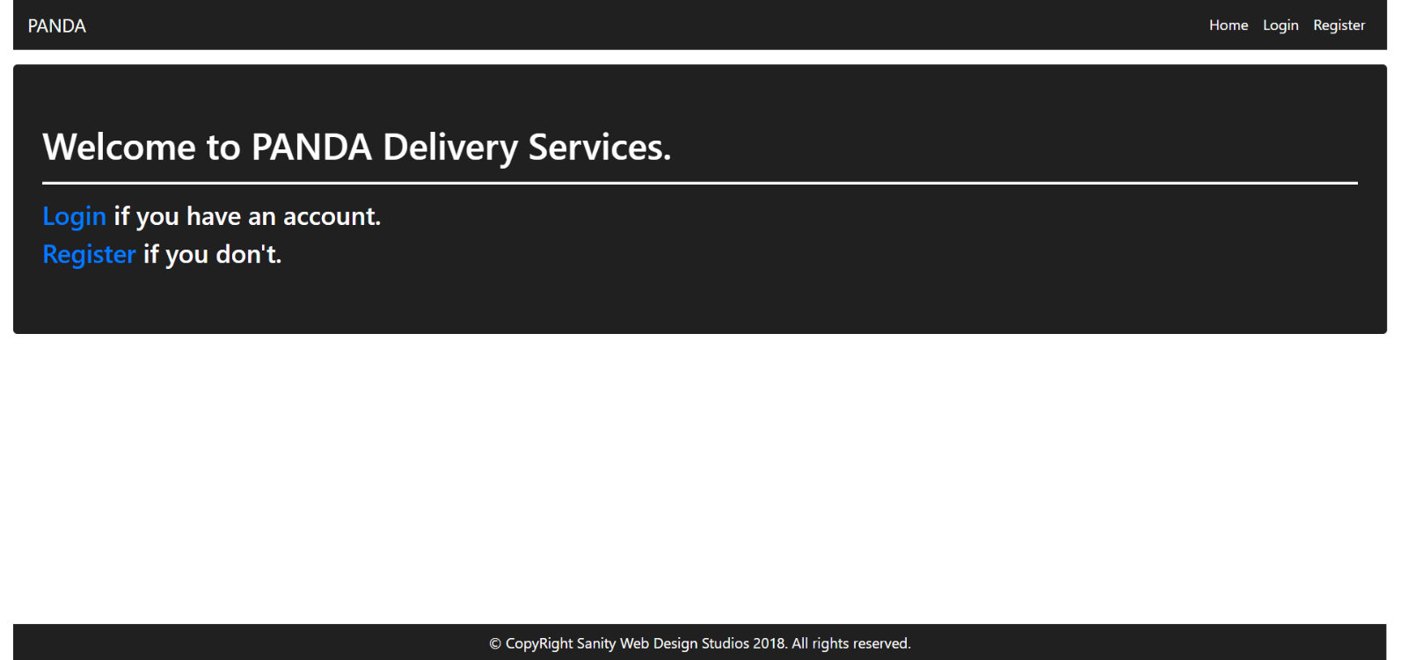

#### Login Template (route = "/login") (logged out user)

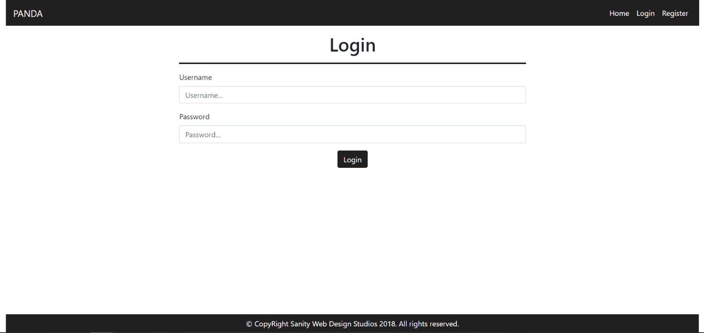

#### Register Template (route = "/register") (logged out user)

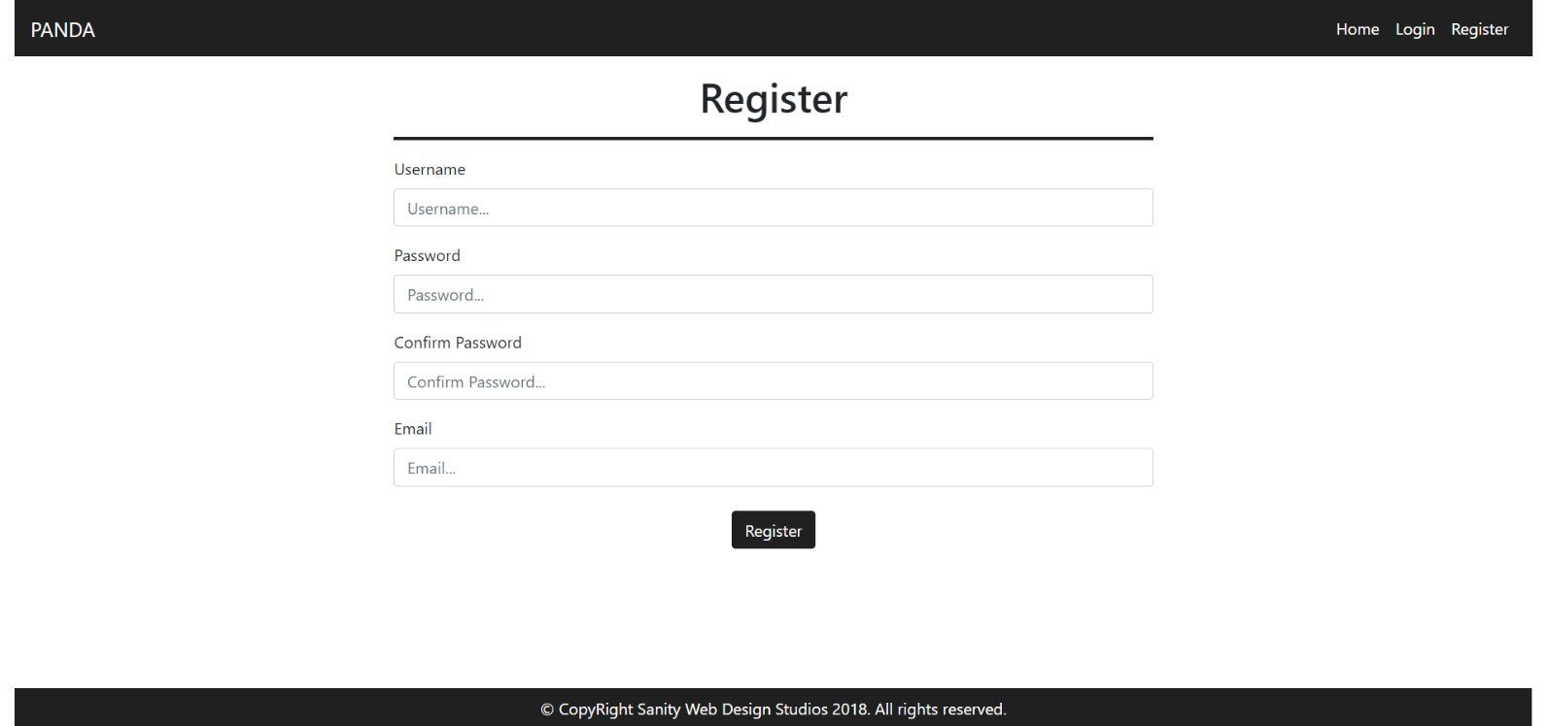

### User Templates

These are the **templates** and **functionalities**, accessible by Users (**logged in** users with Role - User).

#### LoggedIn Index Template (route="/") (logged in user)

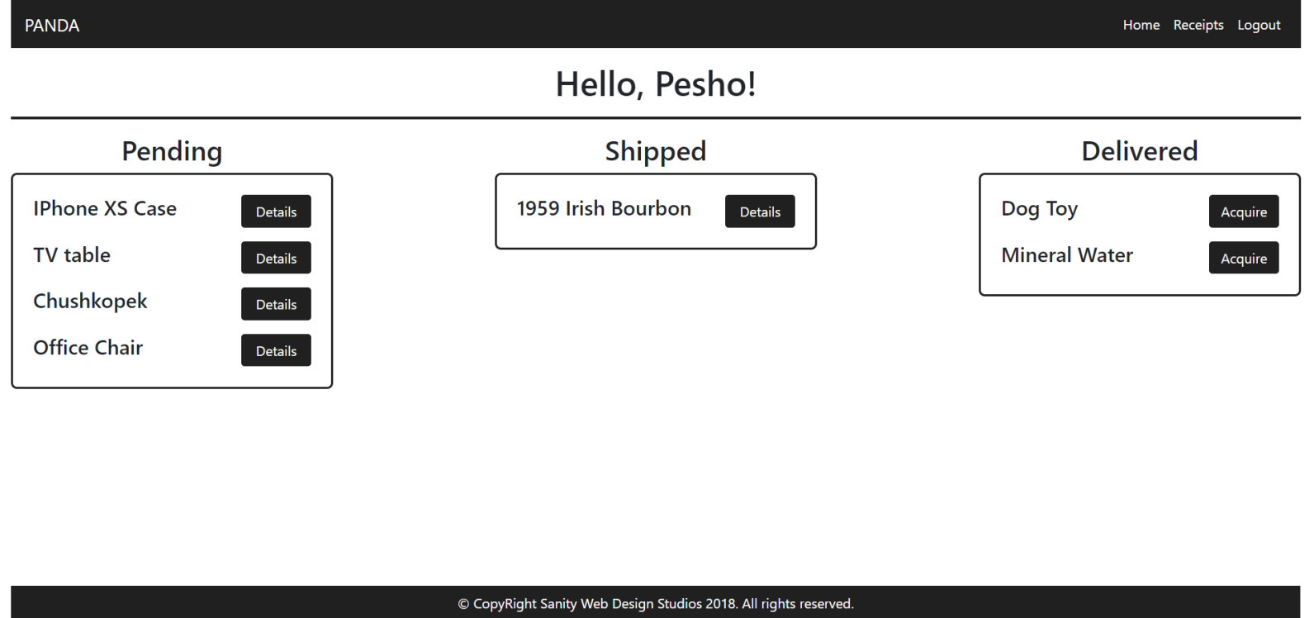

#### Package Details Template (route="/packages/details?id={id}") (logged in user)

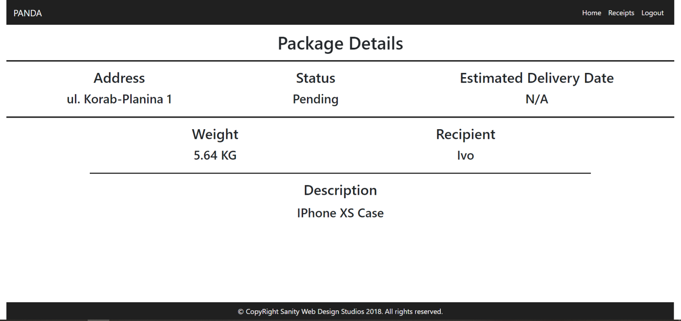

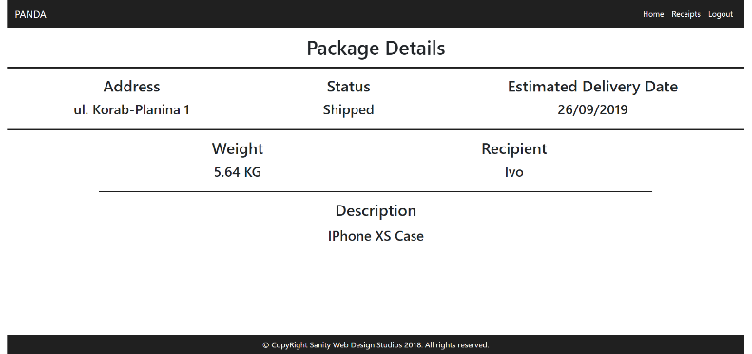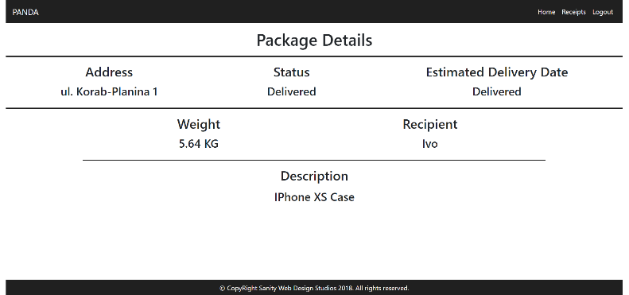

**NOTE**:

* If the **package’s status** is Pending, it should **NOT** have an Estimated Delivery Date, and “N/A” should be presented.
* If the **package’s status** is Shipped, it will have an Estimated Delivery Date. In that case the **date** should presented instead of “N/A”. (Example: “29/02/2016”).
* If the **package’s status** is Delivered or Acquired, instead of the **date**, “Delivered” should be presented.

#### Receipts Template (route="/receipts") (logged in user)

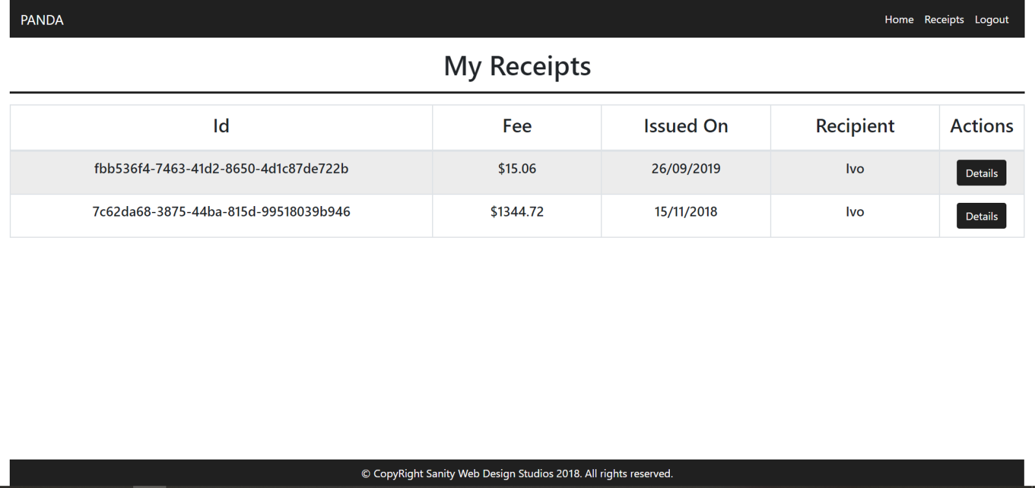

#### Receipt Details Template (route="/receipts/details?id={id}") (logged in user)

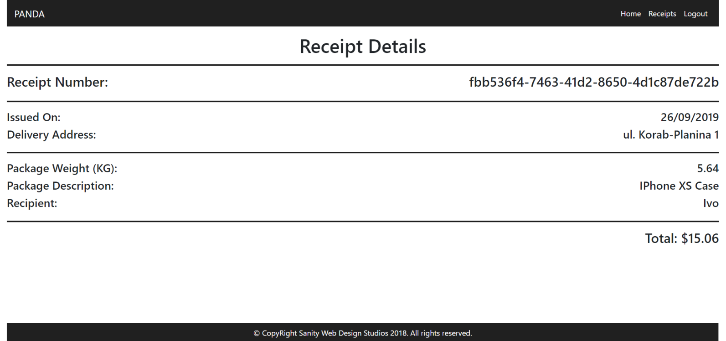

### Admin Templates

These are the **templates** and **functionalities**, accessible by Admins (**logged in** users with Role - Admin).

#### Admin Index Template (route="/") (logged in admin)

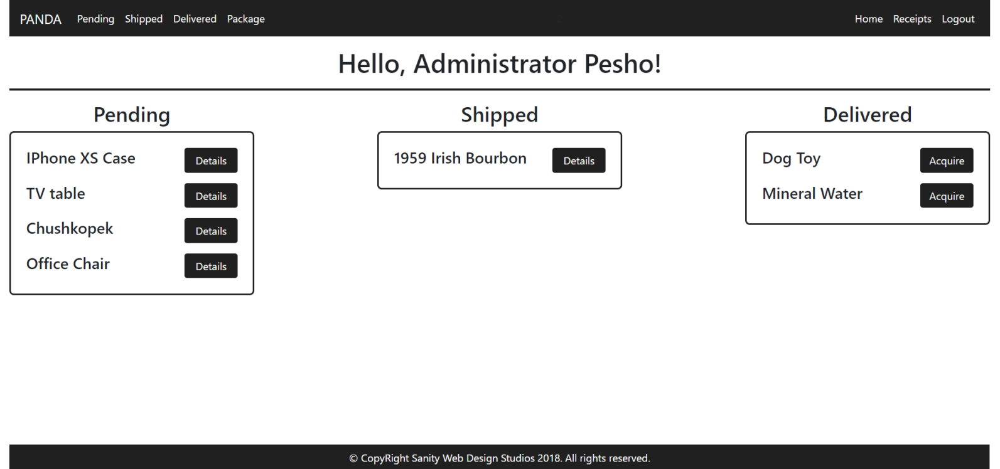

The navigation links above should lead to:

* [**Pending**] – **Pending Packages**
* [**Shipped**] – **Shipped Packages**
* [**Delivered**] – **Delivered Packages**
* [**Package**] – **Create Package**

#### Package Details Admin Template (route="/packages/details?id={id}") (logged in admin)

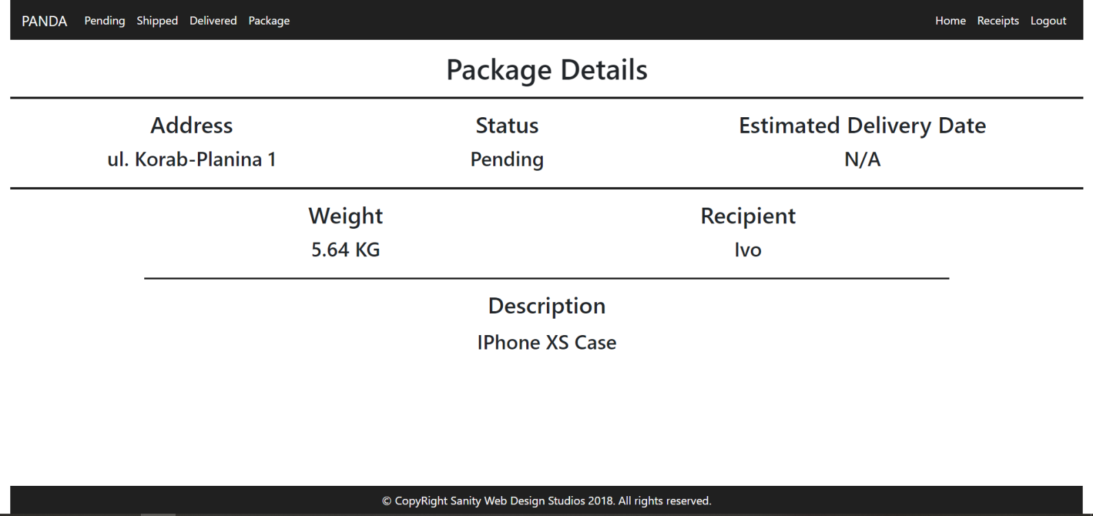

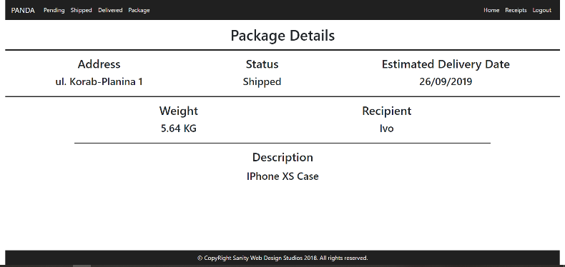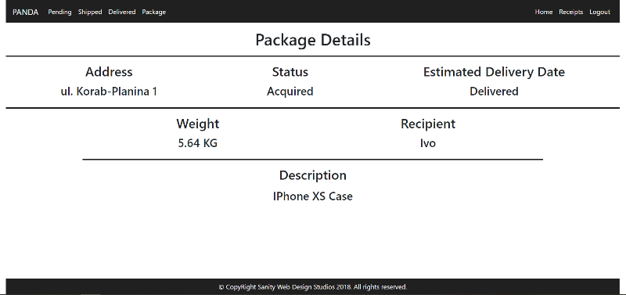

**NOTE**:

* If the **package’s status** is Pending, it should **NOT** have an Estimated Delivery Date, and “N/A” should be presented.
* If the **package’s status** is Shipped, it will have an Estimated Delivery Date. In that case the **date** should presented instead of “N/A”. (Example: “29/02/2016”).
* If the **package’s status** is Delivered or Acquired, instead of the **date**, “Delivered” should be presented.

#### Receipts Admin Template (route="/receipts") (logged in admin)

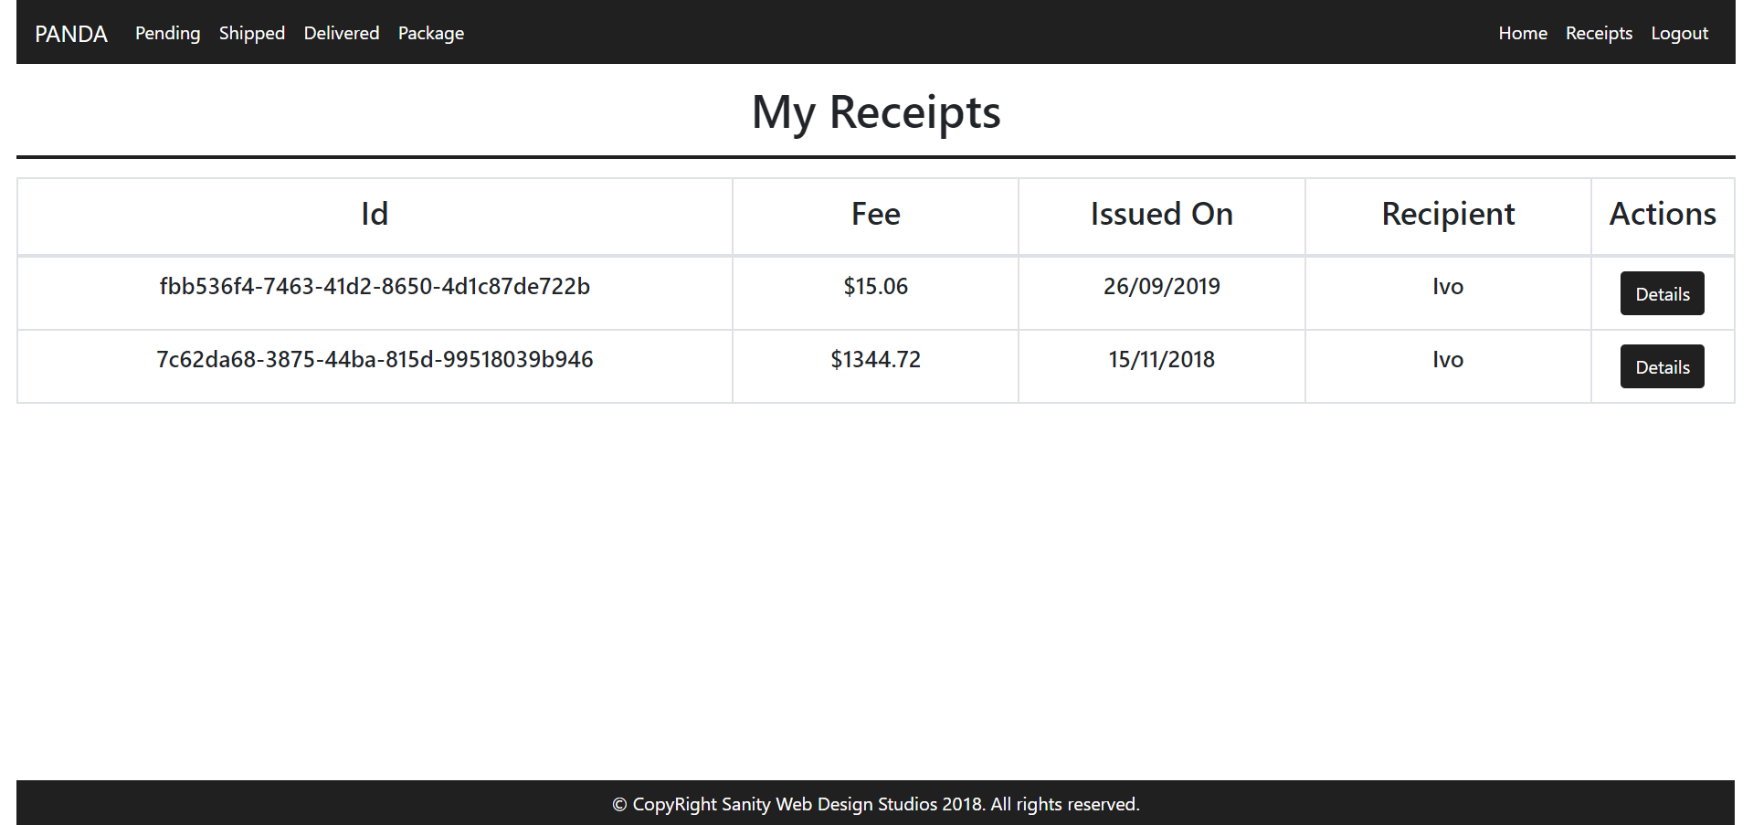

#### Receipt Details Admin Template (route="/receipts/details?id={id}") (logged in admin)

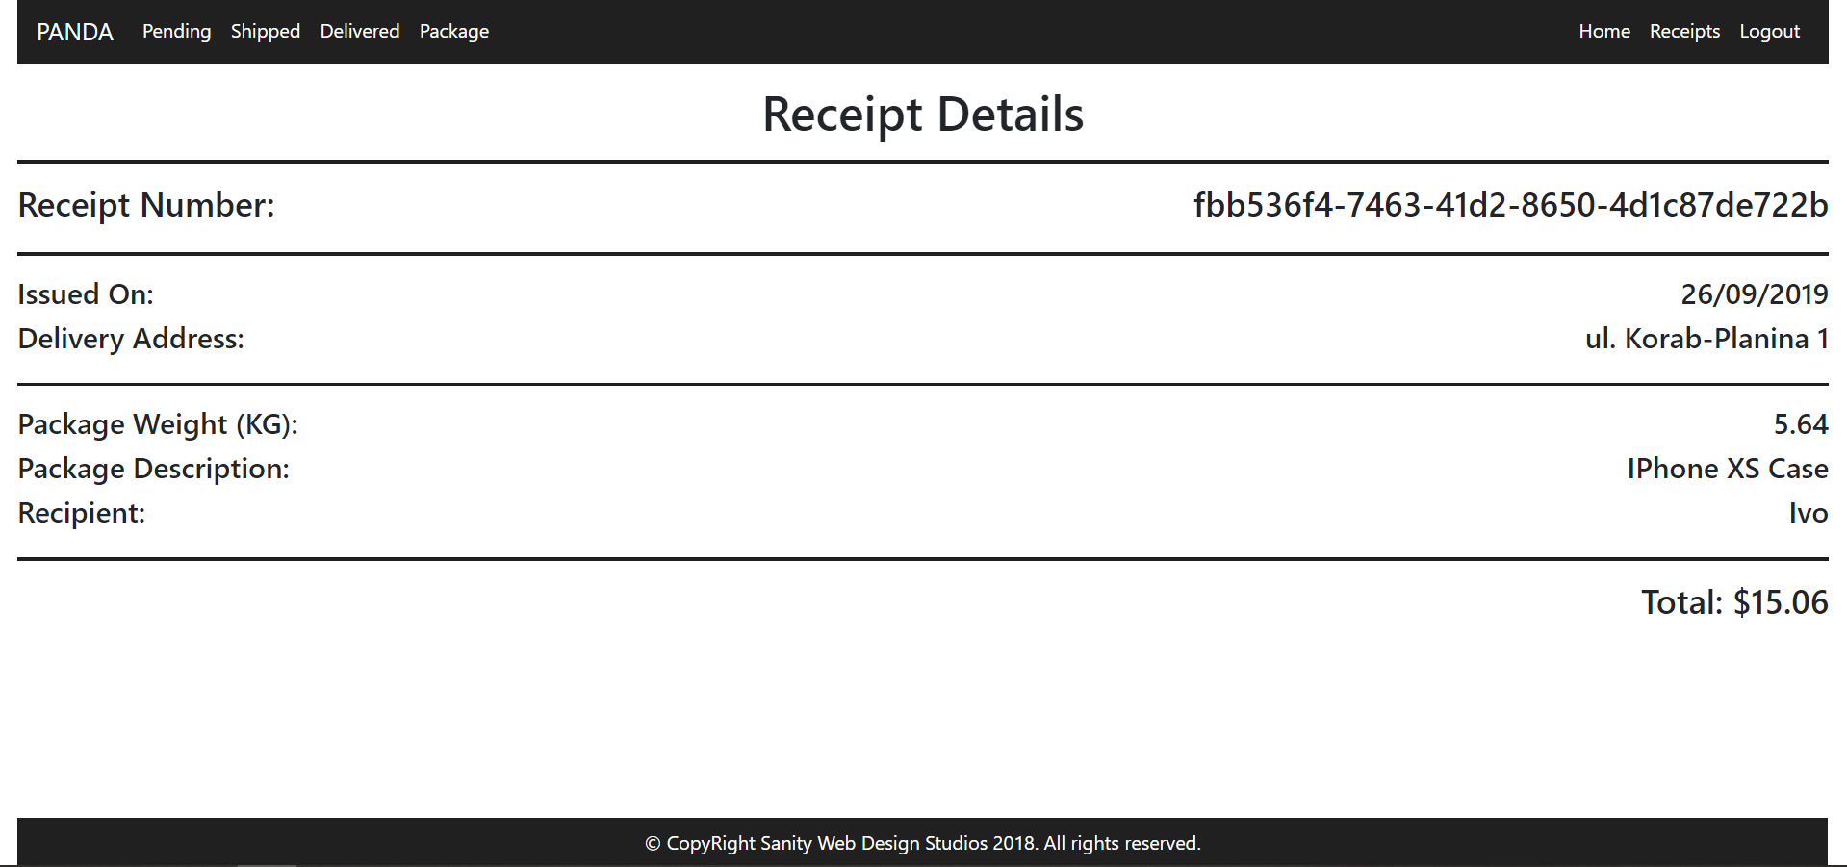

#### Package Create Admin Template (route="/packages/create") (logged in admin)

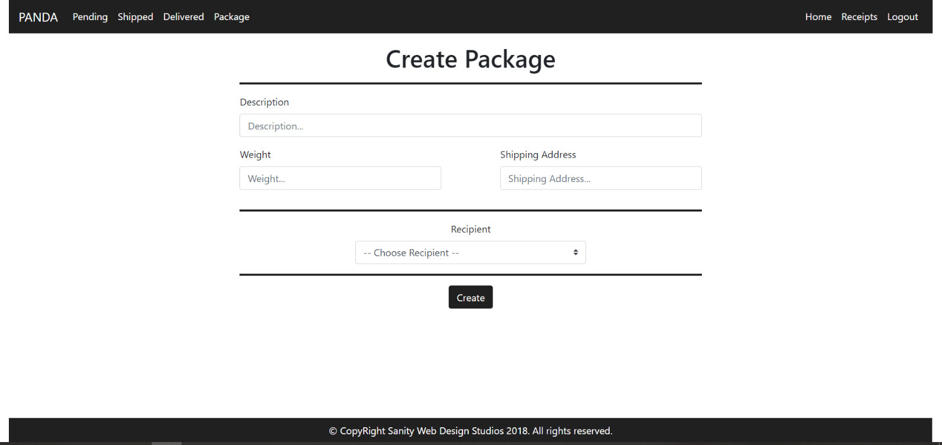

**NOTE**: The **Recipients** field is a **dropdown** **menu**, with **all the registered users** in the **application** (including **yourself**). The **primarily selected** **option** should be "-- Choose Recipient --" and it should be **disabled**, so that it **cannot** be **selected**.

#### Pending Packages Admin Template (route="/packages/pending") (logged in admin)

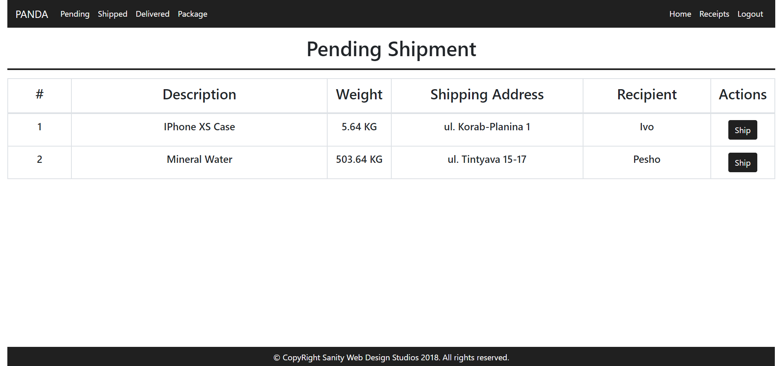

#### Shipped Packages Admin Template (route="/packages/shipped") (logged in admin)

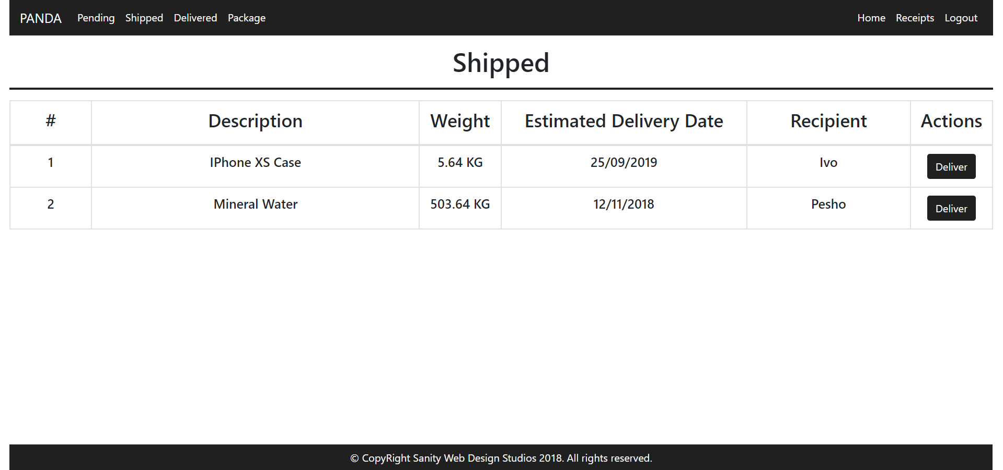

#### Delivered Packages Admin Template (route="/packages/delivered") (logged in admin)

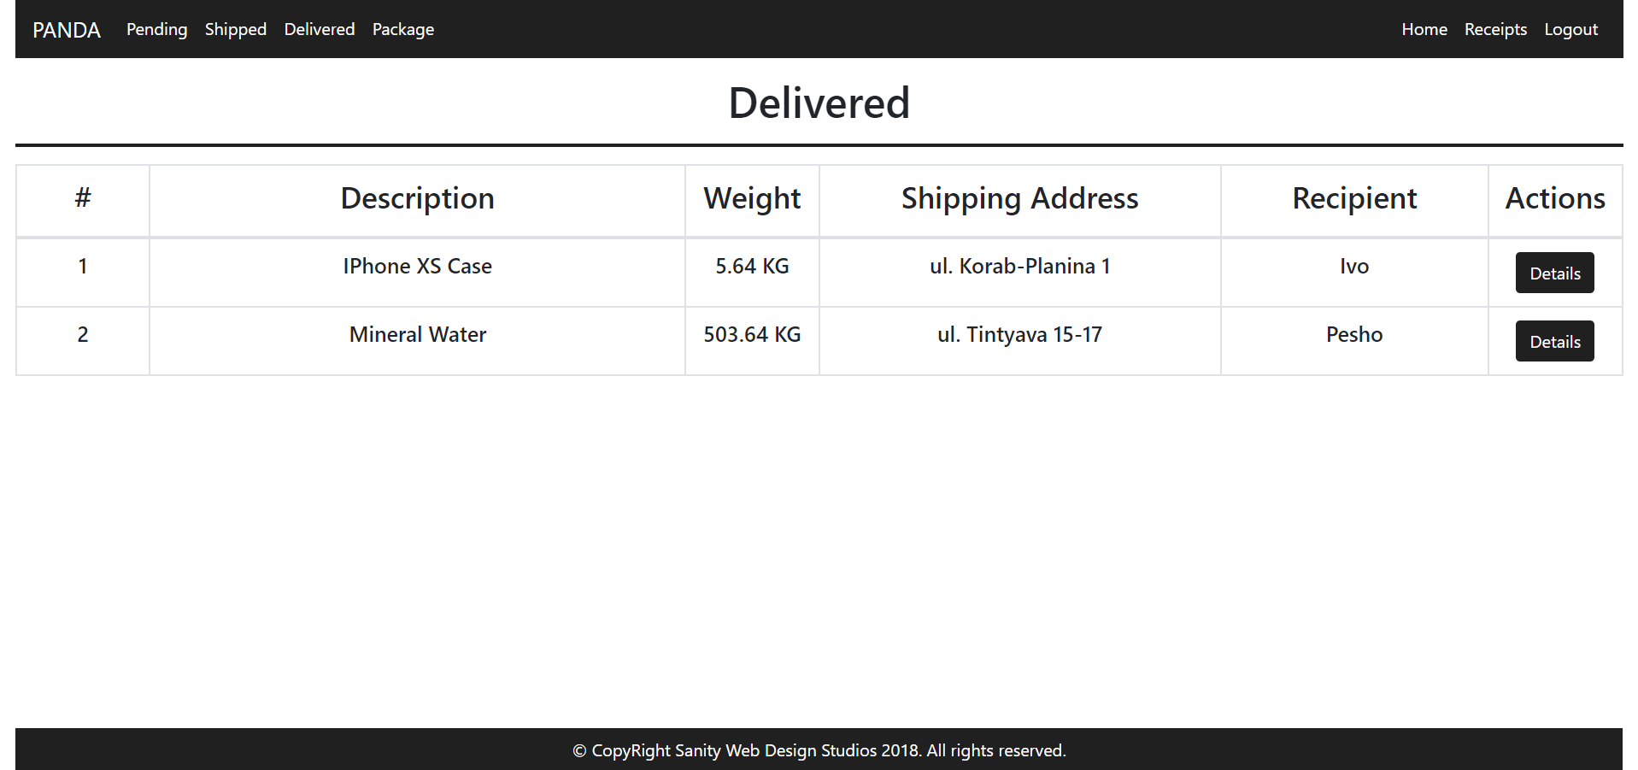

All of the templates will be given to you in the form of HTML files, so make sure you implement your pages correctly.

**NOTE**: The templates should look **EXACTLY** as shown above.

**NOTE**: The templates do **NOT** **require** **additional** **CSS**. Only **bootstrap** and the given **style.css** are enough.

**NOTE**: In the given **style.css** you’ll see some helpful classes “bg-panda”, “text-panda”, “border-panda”. “border-panda” will help you with the **border** of the **blocks** on the **Index Pages**.

## Functional Requirements

The Functionality Requirements describe the functionality that the **Application** must support.

The **application** should provide Guest (not logged in) users with the functionality to:

* Login
* Register
* View the Guest Index page

The **application** should provide Users (logged in) with the functionality to:

* Logout
* View their Packages
* View details about a Package
* View their Receipts
* View details about a Receipt

The **application** should provide Admins (logged in, with role - Admin) with the functionality to:

* Logout
* View their Packages
* View details about a Package
* View their Receipts
* View details about a Receipt
* View all Pending Packages
* View all Shipped Packages
* View all Delivered Packages
* View details about all Delivered Packages
* Ship Packages
* Deliver Packages

### Users

The **first registered** User should be **assigned** a **role** – "Admin". Every User after that, should have a **role** – "User".

Users have Packages, which are **created** and **controlled** for them, by an Administrator.

Users can **view** **Details** about their **own** Packages.

When a Package is **delivered**, a User can **acquire** it, at which point a Receipt is **created** with **that** Package and **that** User.

Users can **view** their Receipts, and **details** about each Receipt.

Administrators (role = "Admin") are essentially like normal Users. They can also have Packages, which are **delivered**, **acquired** and they also have Receipts.

Administrators can also **create** Packages for a specific User.

* They can also **view** all Pending Packages, and they can Ship them.
* They can also **view** all Shipped Packages, and they can Deliver them.
* They can also **view** all Delivered Packages, and they can view Details about them.

### Packages

When Packages are **created**, they are **created** with a Description, a Weight, a Shipping Address and a Recipient User.

* Upon creation, the Status of a Package should be set to Pending.
* Upon creation, the Estimated Delivery Date of a Package should be set to NULL.

#### Functionality

##### Pending Packages

A Pending Package, can be Shipped by an Administrator, by clicking on the [Ship] button from the Pending Packages Page. At that moment the Package Status becomes "Shipped" and the Estimated Delivery Date is to be set to a **random** of **20**-**40** days from then.

* All Pending Packages are presented on the Pending Packages Page.
* A User can view his Pending Packages on his Index Page in the Pending rectangular block.
* A User can **view details** about each one of his Pending Packages from his Index Page, by clicking on the [Details] button.

##### Shipped Packages

A Shipped Package, can be Delivered by an Administrator, by clicking on the [Deliver] button from the Shipped Packages Page. At that moment the Package Status becomes "Delivered".

* All Shipped Packages are presented on the Shipped Packages Page.
* A User can view his Shipped Packages on his Index Page in the Shipped rectangular block.
* A User can **view details** about each one of his Shipped Packages from his Index Page, by clicking on the [Details] button.

##### Delivered Packages

A Delivered Package, can be Acquired by the Package’s Recipient, by clicking on the [Acquire] button from his Index Page. At that moment the Package Status becomes "Acquired" and a Receipt is **generated** to the User for that Package.

* All Delivered Packages are presented on the Delivered Packages Page.
* A User can view his Delivered Packages on his Index Page in the Delivered rectangular block.
* A User can Acquire each one of his Delivered Packages from his Index Page, by clicking on the [Acquire] button.

**NOTE**: The **INDEX PAGE** visualizes **ONLY** the **CURRENTLY LOGGED IN USER / ADMIN’s** **PACKAGES**.

**NOTE**: Acquired Packages are viewable only by Administrators on the Delivered Packages Page.

**NOTE**: Administrators can **view** **details** about **ALL** Delivered / Acquired Packages from the  
Delivered Packages Page, by clicking on the [Details] button.

### Receipts

Receipts are just data entities. They are **created** when a Package is Acquired by its Recipient User.   
A Receipt should be **created** with a Package and a Recipient User.

Upon creation, a Receipt’s Fee should be **set** to the Package’s Weight **multiplied** (*) by 2.67.

Upon creation, a Receipt’s IssuedOn should be set to the **current moment**.

## Security Requirements

The Security Requirements are mainly access requirements. Configurations about which users can access specific functionalities and pages.

* Guest (not logged in) users can access Index page and functionality.
* Guest (not logged in) users can access Login page and functionality.
* Guest (not logged in) users can access Register page and functionality.
* Users (logged in) can access User LoggedIn Index page and functionality.
* Users (logged in) can access User Package Details page and functionality.
* Users (logged in) can access User Receipts page and functionality.
* Users (logged in) can access User Receipt Details page and functionality.
* Users (logged in) can access User Package Acquire functionality.
* Users (logged in) can access Logout functionality.
* Admins (logged in) can access **every functionality** a **normal** logged in User can.
* Admins (logged in) can access Admin LoggedIn Index page and functionality.
* Admins (logged in) can access the Admin Package Create page and functionality.
* Admins (logged in) can access the Admin Pending Packages page and functionality.
* Admins (logged in) can access the Admin Shipped Packages page and functionality.
* Admins (logged in) can access the Admin Delivered Packages page and functionality.
* Admins (logged in) can access the Admin Package Ship functionality.
* Admins (logged in) can access the Admin Package Deliver functionality.